

Practices for Secure Software Report

Table of Contents
Document Revision History 3
Client 3
Instructions 3
Developer 4
1. Algorithm Cipher 4
2. Certificate Generation 4
3. Deploy Cipher 4
4. Secure Communications 4
5. Secondary Testing 4
6. Functional Testing 4
7. Summary 4
8. Industry Standard Best Practices 4

Document Revision History

Version | Date | Author | Comments
1.0 | 2/18/2026 | Parker Burkard

Client



Instructions

Submit this completed practices for secure software report. Replace the bracketed text with the relevant information. You must document your process for writing secure communications and refactoring code that complies with software security testing protocols.

- Respond to the steps outlined below and include your findings.
- Respond using your own words. You may also choose to include images or supporting materials. If you include them, make certain to insert them in all the relevant locations in the document.
- Refer to the Project Two Guidelines and Rubric for more detailed instructions about each section of the template.

Developer
Parker Burkard

Algorithm Cipher

Artemis Financial must protect their clients’ personal and financial information from attacks. I would recommend using the Advanced Encryption Standard (AES) algorithm cipher to protect their data. AES is a symmetric block cipher that was adopted by the USA government in 2001. This cipher can be implemented via cryptographic keys of 128, 192, or 256 bits. AES provides security against brute force attacks as the cipher can take thousands of years to crack. While it may not be necessary for Artemis Financial to use the 256-bit cipher as that requires more processing power than the 128 or 192-bit ciphers, it isn’t a bad idea to go with the most secure cipher when handling customer’s financial information. As I mentioned earlier, AES is a symmetric block cipher which means that the same key is used for both encryption as well as decryption. This means that whoever is sending the data must provide the key to the person receiving the data as the same key is used. This does open itself up to data breaches as the sender must be certain of who they are sending the data to, but when combined with other tools such as a multi-factor authentication could ensure that data is not being stolen.
Hash functions protect data integrity and prevent attacks from malicious parties. AES utilizes AES-hash which is a secure hash function that takes an arbitrary bit string as an input and then returns it as a fixed length string output. This is to ensure each input provides a unique output and makes it nearly impossible to find two files with the same hash. AES was created after the previous encryption standard Data Encryption Standard (DES) started to become vulnerable to attacks, so a new system was needed. AES was designed to be effective for many years and is easily implemented in software, while it was created for government use, it is also free and available for public use and is secured through the National Institute of Standards and Technology (NIST).

Certificate Generation
Insert a screenshot below of the CER file.

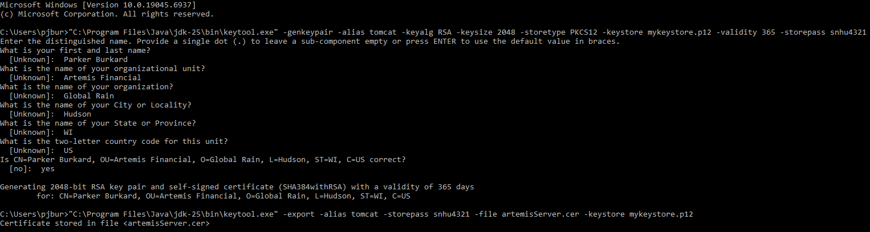

Deploy Cipher
Insert a screenshot below of the checksum verification.

Secure Communications
Insert a screenshot below of the web browser that shows a secure webpage.

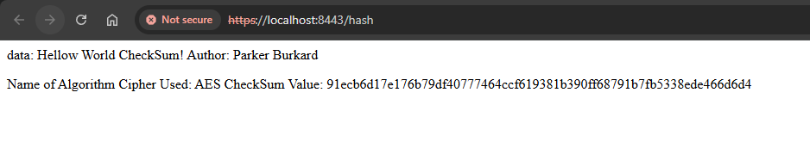

Secondary Testing
Insert screenshots below of the refactored code executed without errors and the dependency-check report.

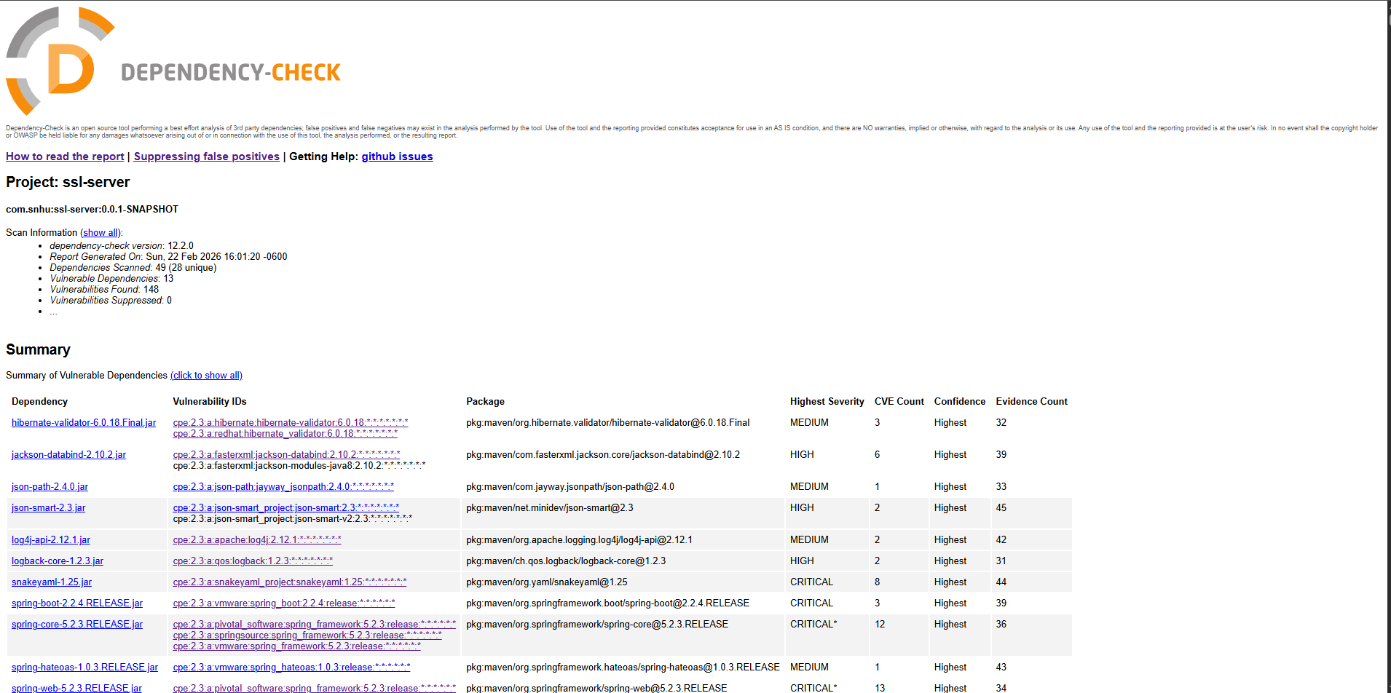

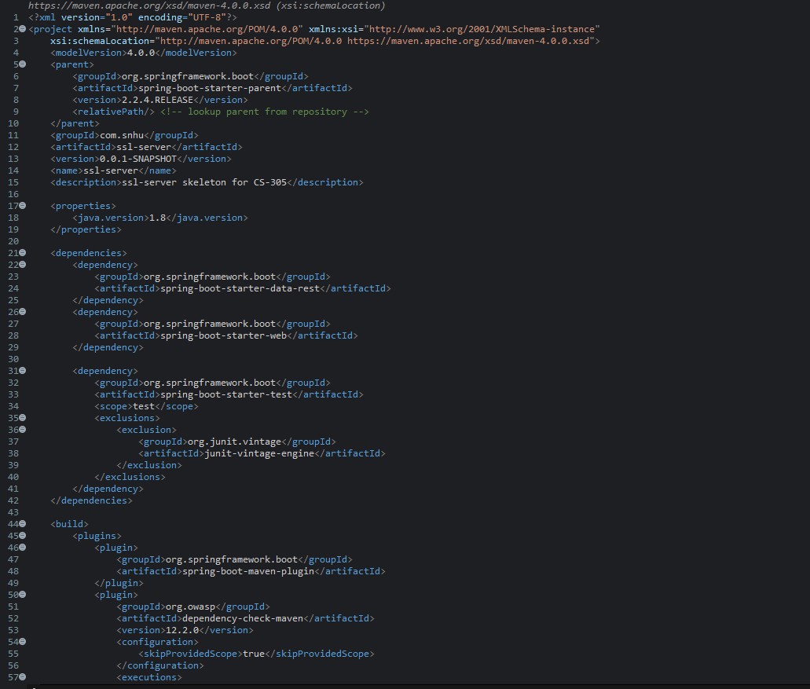
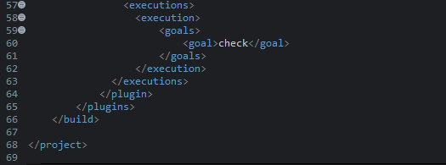

Functional Testing
Insert a screenshot below of the refactored code executed without errors.

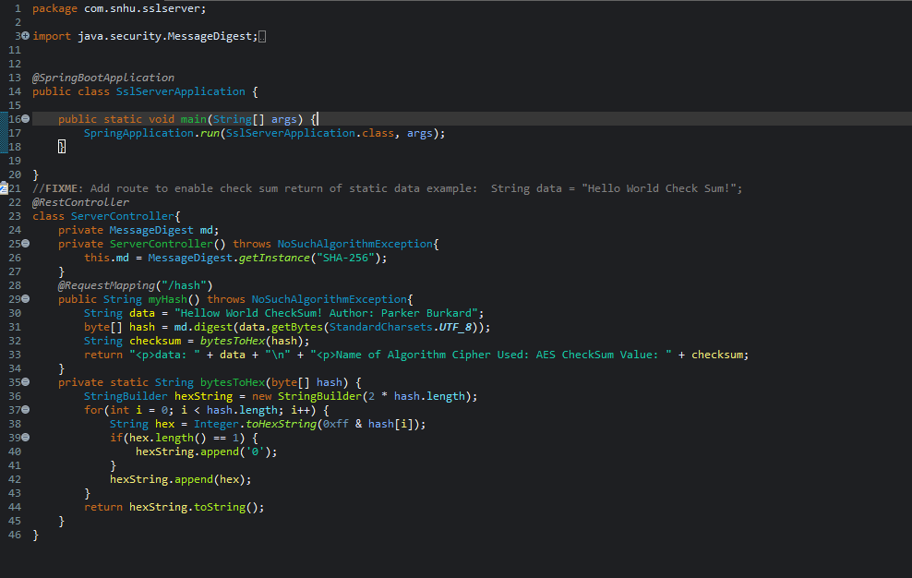

Summary

When I was refactoring the code, I implemented AES encryption functionality to increase the security of Artemis Financial’s data. Utilizing this encryption transitioned the output from HTTP to HTTPS which is more secure to prevent attacks. I also ran a Maven Dependency Check to find vulnerabilities in the code and conducted functional testing to validate the program. I also made some modifications to the pom.xml file as I updated the Maven Dependency Check version from 5.3.0 to 12.2.0 to ensure that my dependency check is as up to date as possible. I also added a line in the pom file to skip the provided scope which skips artifacts that are not bundled in distribution.

Industry Standard Best Practices

Some industry standard practices that I implemented in this code were to secure the storage and transmission of data through Artemis Financial by changing the output from HTTP to HTTPS. I also ensured that only users with the correct password can decrypt the data and help reduce the risk of attacks on the system. In order to keep the system secure there must be consistent updates and any vulnerabilities that arise must be fixed. Applying these industry standard best practices will help ensure that Artemis Financial’s clients’ data is well protected, which will keep their clients happy and ensure that the company stays successful.

